COSC 641
Spring 2020
FSU

Bank of Frostburg State University

Database Final Project
COSC 641 Part 1b and 1c

Continuation of project. Please write your assumptions (if any)

Chapter 10
Write Subprograms and Packages with exception handling: (make sure your subprograms have appropriate exception handling)

- Procedure to write all daily (today) deposit into a database table called Today_Deposit. (all deposits for that day)

- Procedure to write all daily (today) withdraw into a database table called Today_Withdraw. (all deposits for that day)

Use SYSDATE to get today’s date.
The structure of Today_Withdraw and Today_Deposit are:
(Date & Time, Account number, Account Type, Amount)

- Procedure to transfer $x from one account to another account. Also write the FROM account number, to TO account number, the amount and the date of transaction into a Transaction_Log file (table).
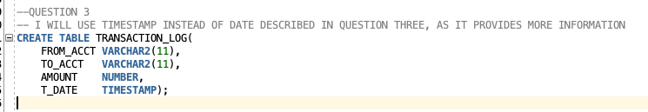
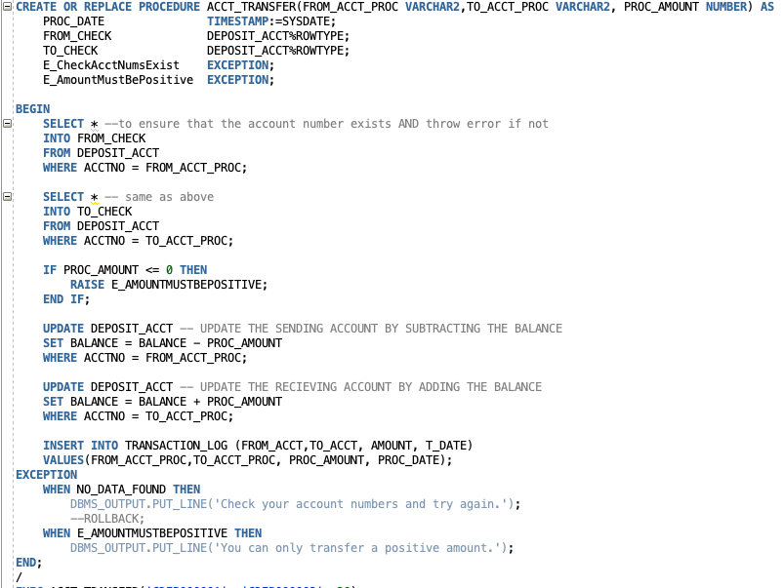
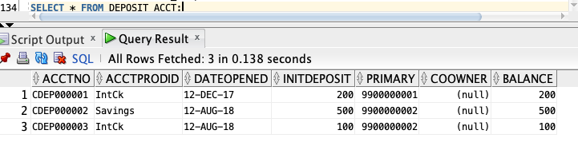
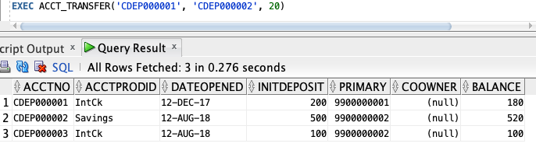
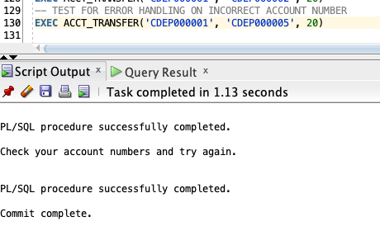
No funds were transferred.
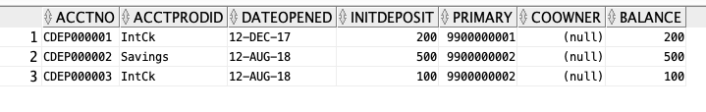
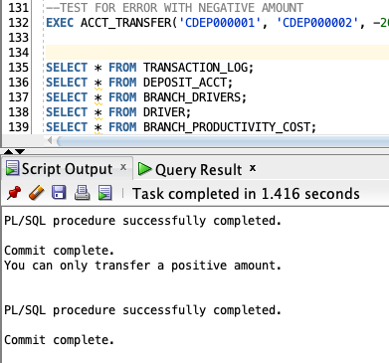
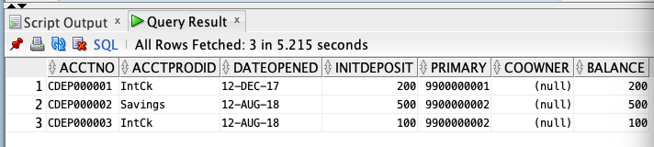

- Create a subprogram called Birthday_sub that accepts today’s date as default and writes the first name, last name, and address of a customer whose birth date (day and month only) is 15 days from today’s date. Write them into a temp file (table called B_C_File).

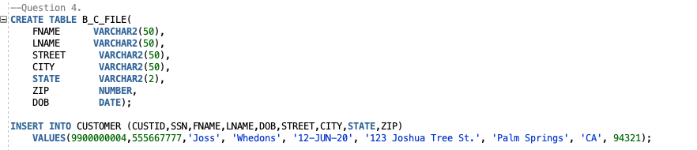

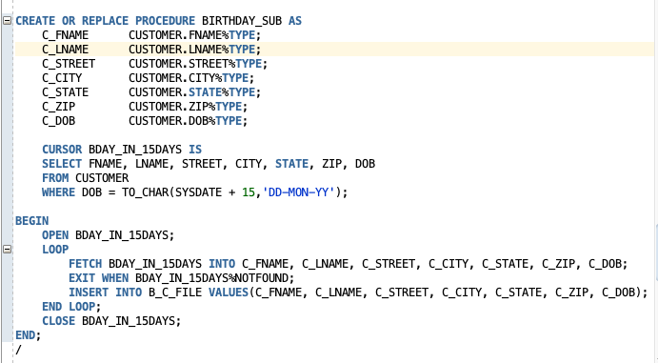

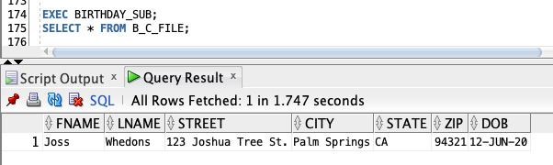

- Create a function called CustomerInfo to accept a customer account number and return the total deposit for the customer account.
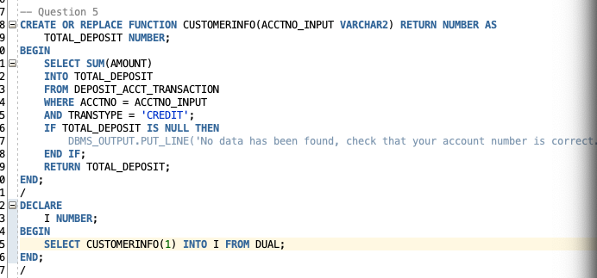
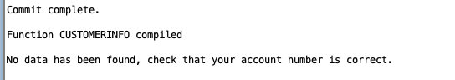
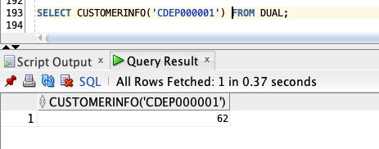

- Create a function with the same name CustomerInfo (overload) to accept a customer account number and a date; and return the total deposit of that customer account for that date.
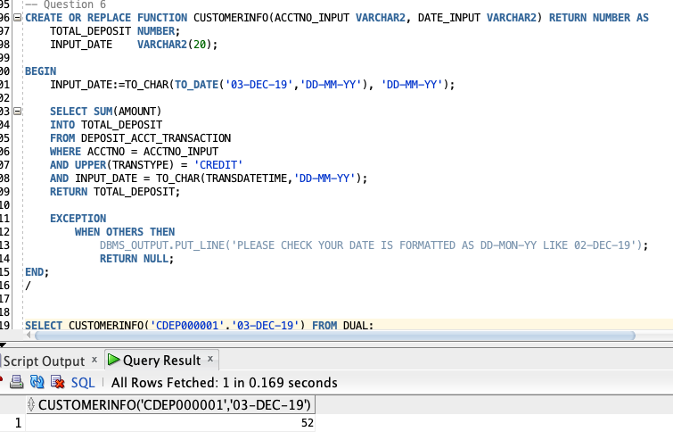
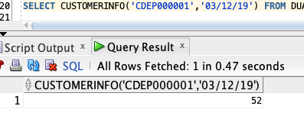

- Create a function with the same name CustomerInfo (overload) to accept a customer ID, a date and a co-owner account number, and return the total deposit of that joint account for that date.

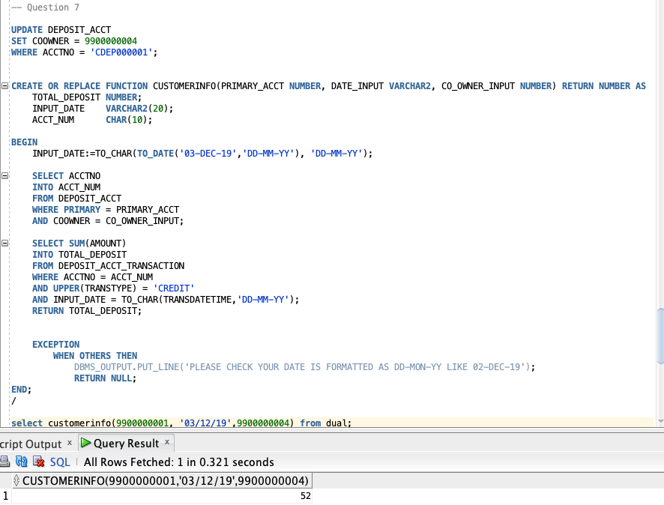

- Procedure to list the last 10 transactions of a customer by passing Customer Id.
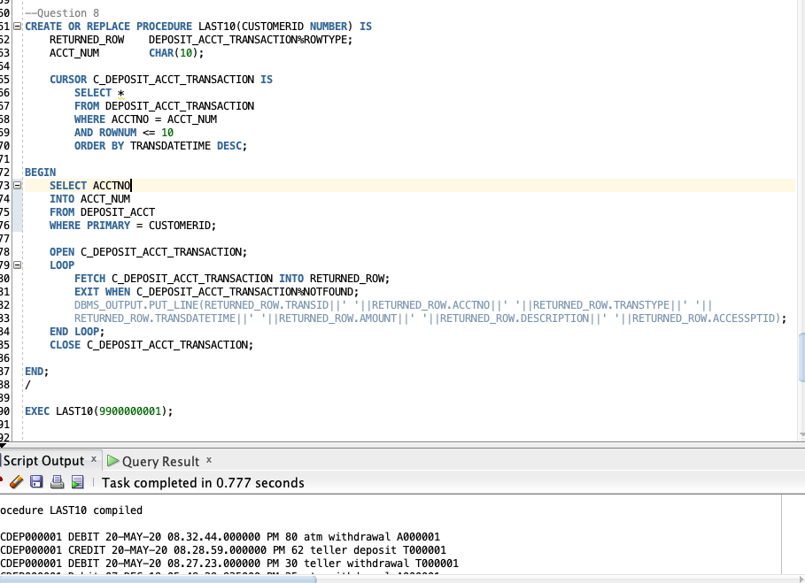
- Create a package with the following functions called BankP for each customer (customer id):
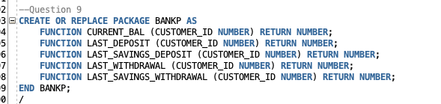
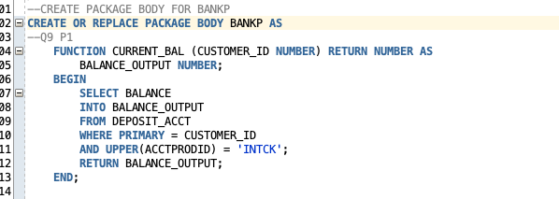
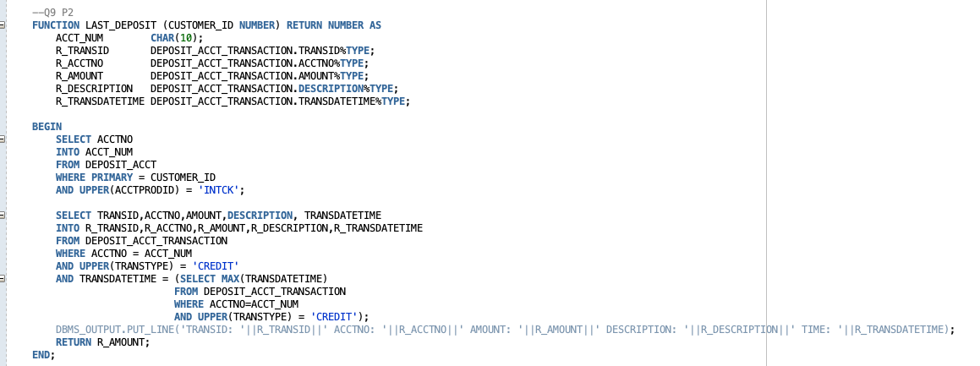
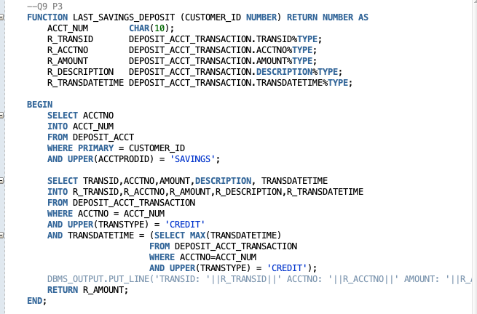
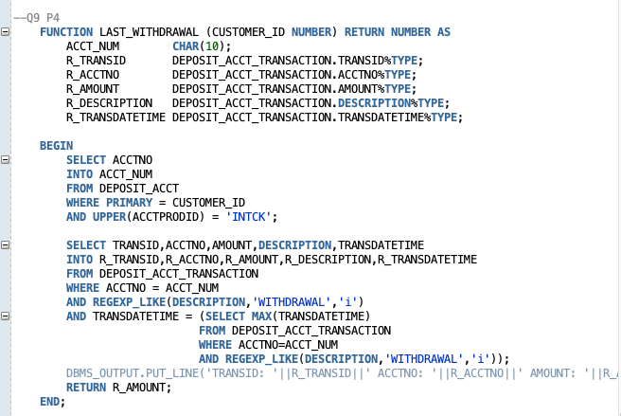
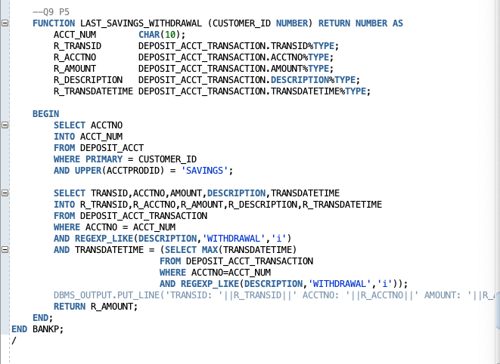

- Function to return the current balance.
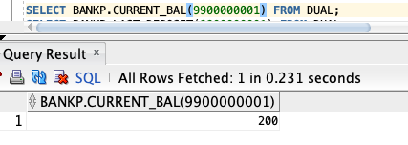
- Function to return the last deposit from checking.
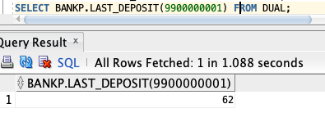
- Function to return the last deposit from saving
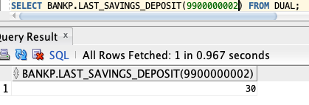
- Function to return the last withdraw from checking.
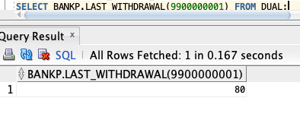
- Function to return the last withdraw from saving.
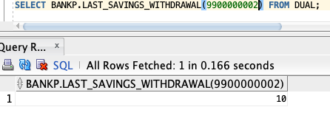

- Create a package with the following functions & procedures called BranchP by branch id.
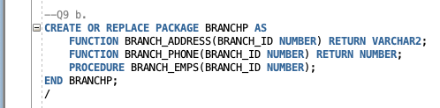
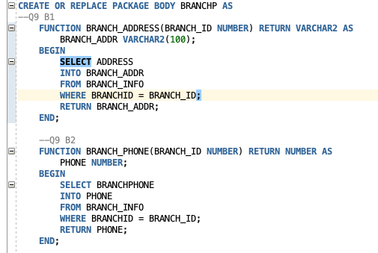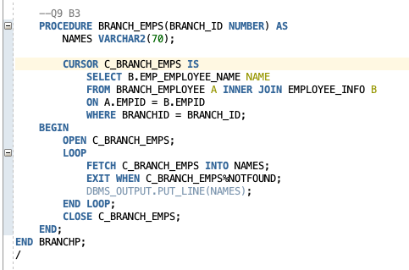

- Function to return the current branch address.
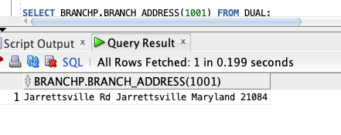
- Function to return the current branch phone number.
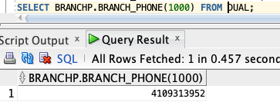
- Procedure to output the name of employees working at that branch.
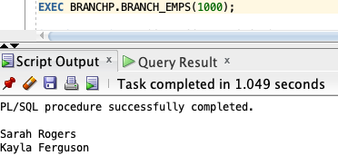

- Create a package called Insert_pkg with subprograms to automate the insert, delete, and update of data in your database.
    - Subprogram to insert a row in table customer (make sure you use the sequence for generating ID’s)
    - Subprogram to insert a row in table bank employee
    - Subprogram to insert a row in table CD
    - Subprogram to insert a row in table driver.
    - Subprogram to delete a row from table driver.
    - Subprogram to update a row in table driver.

- Create a useful package of your choice with functions, procedures, and datatype of your own.

Chapter 11

Create the following triggers:
- Any deletion from employee file, trigger to write OLD attributes into an Employee_History file. 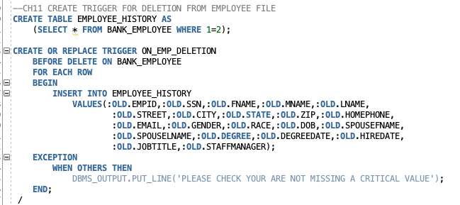
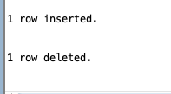
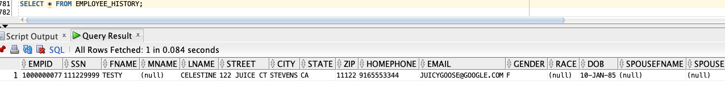

- Any modification to the customer accounts, write who, date, and the nature of (OLD and NEW) modification into a Cust_Mod_Log file.
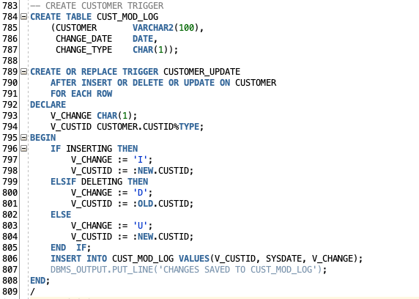
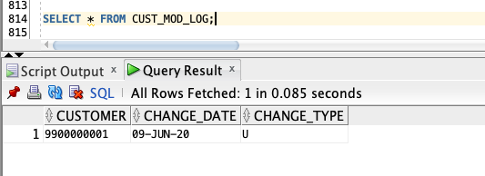
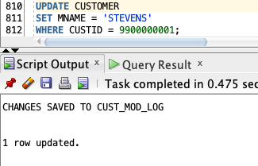
- Any deposit larger that $5000 to any account will also be written in a Large_Dep_Log file. 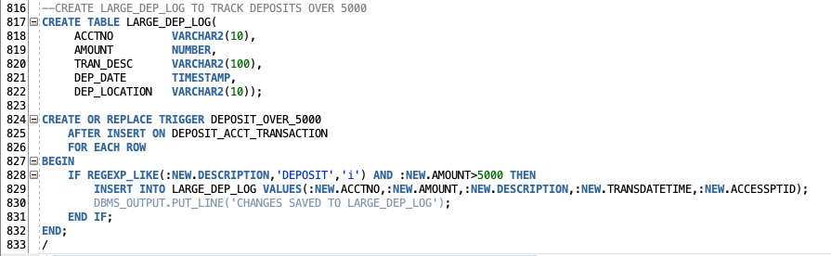
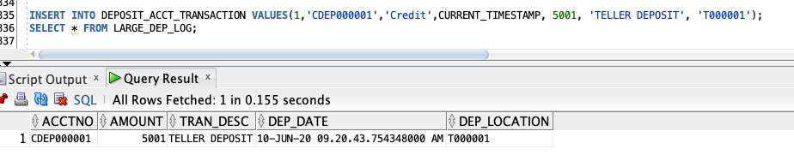
- Any withdraw larger than $10000 from any account also will be written in a Large_With_Log file.

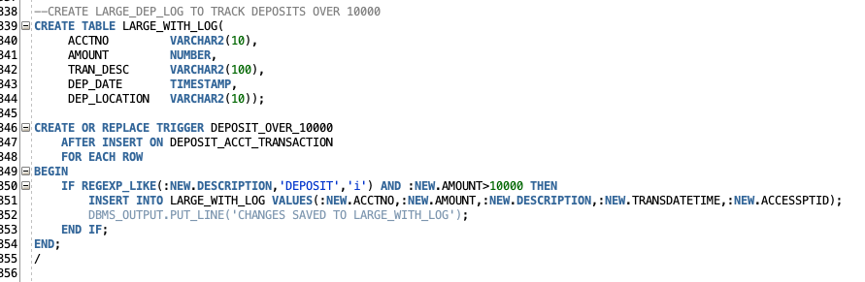
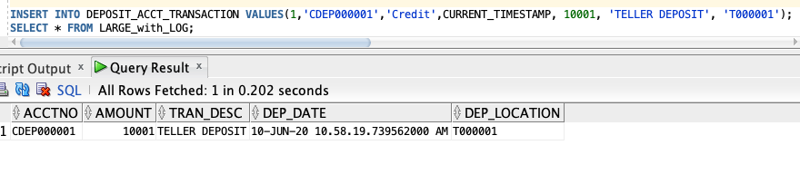

Chapter 12

All the errors generated by your run-time programs must be stored into an Error_log file. We would like to know the name of table, trigger name, the date, trigger event, and the trigger type.
